Synopsis

Predictive Analysis of Disease Risk Using Supervised Machine Learning
Problem Id: 1

Team Leader: Ananya Namdev
University Roll No: 2028638
Section: K

Team Member: Manashvi Kandwal
University Roll No: 2028451
Section: K

Team Member: Neveda Mittal
University Roll No: 2028456
Section: K

- Problem Description:
The increasing prevalence of chronic diseases has created a need for early and accurate risk prediction systems that can assist healthcare professionals in making informed decisions. Patient clinical data such as age, medical history, laboratory test results, and lifestyle factors contain valuable information that can help identify individuals at higher risk of developing certain diseases. However, analyzing large volumes of medical data manually is time-consuming and prone to errors.
The objective of this project is to design and develop an end-to-end machine learning classification system that predicts disease risk using patient clinical data. The system will involve collecting a suitable clinical dataset and performing essential data preprocessing steps including data cleaning, normalization, and transformation to ensure data quality and consistency. Important features will be selected using appropriate feature selection techniques to improve model performance and interpretability.
The processed data will then be used to train multiple classification models including Logistic Regression, K-Nearest Neighbours (KNN), and Support Vector Machine (SVM). The models will be evaluated using performance metrics such as accuracy, precision, recall, F1-score, confusion matrix, and ROC curve to determine the most effective approach for disease risk prediction.

- Steps of Implementation:
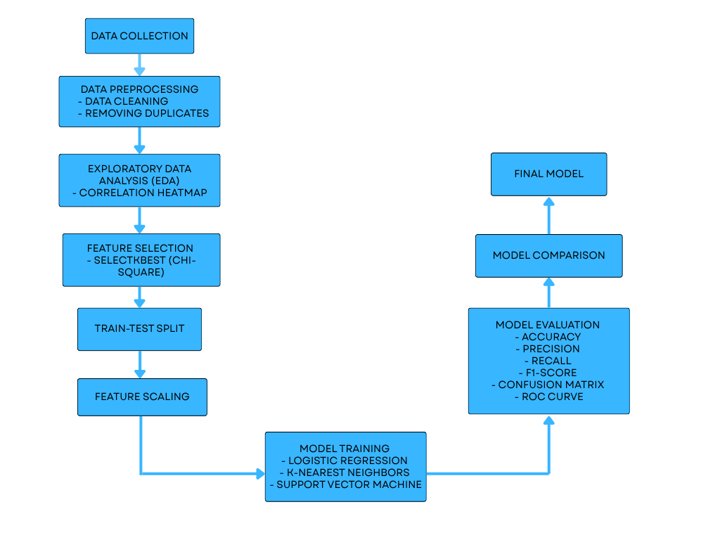

1. Data Collection
This is the first step where a relevant clinical dataset is obtained. The dataset contains patient-related information such as age, gender, blood pressure, cholesterol level, glucose level, BMI, smoking habits, or medical history. These variables act as features that help the machine learning model learn patterns related to disease risk. The dataset may be collected from open medical repositories, healthcare databases, or research datasets.

2. Data Preprocessing
Data preprocessing prepares the raw dataset for analysis and model training.
- Data Cleaning: Missing values, inconsistent entries, or incorrect data are handled or removed to improve data quality.
- Removing Duplicates: Duplicate patient records are eliminated to prevent bias and ensure each observation represents a unique case.
This step ensures the dataset becomes accurate, consistent, and suitable for analysis.

3. Exploratory Data Analysis (EDA)
EDA helps understand the structure and relationships within the dataset before building models. Statistical summaries and visualizations are used to identify patterns, trends, and possible anomalies.
- Correlation Heatmap: A visual representation showing how strongly different features are related to each other and to the target variable (disease risk). This helps identify important or redundant features.

4. Feature Selection
Feature selection identifies the most relevant variables that influence disease prediction.
- SelectKBest (Chi-Square): This technique selects the top features that have the strongest statistical relationship with the target variable. Removing irrelevant features helps improve model performance, reduce complexity, and increase interpretability.

5. Train-Test Split
The dataset is divided into two parts:
- Training set: Used to train the machine learning models.
- Testing set: Used to evaluate how well the model performs on unseen data.
This step ensures that the model is tested fairly and does not simply memorize the training data.

6. Feature Scaling
Feature scaling standardizes numerical features so they fall within a similar range. Algorithms like KNN and SVM are sensitive to the scale of data, so scaling helps ensure fair contribution of all features and improves model accuracy.

7. Model Training
Different classification algorithms are trained using the processed dataset.
- Logistic Regression: A statistical model used for binary classification that predicts the probability of disease risk.
- K-Nearest Neighbors (KNN): Classifies patients based on similarity to nearby data points in the dataset.
- Support Vector Machine (SVM): Finds an optimal boundary (hyperplane) that separates patients into different risk categories.

Justification of Models Used

Logistic Regression
Logistic Regression is used because it is a simple and effective algorithm for binary classification problems, such as predicting whether a patient is at risk of disease or not. It provides probabilistic outputs, which makes the results easy to interpret in medical applications. It also works well when the relationship between features and the target variable is approximately linear.

K-Nearest Neighbors (KNN)
KNN is used because it classifies data based on similarity between data points. In medical datasets, patients with similar clinical features often have similar disease outcomes. KNN is easy to implement and can capture patterns in the data without making strong assumptions about the data distribution.

Support Vector Machine (SVM)
SVM is used because it is effective in high-dimensional datasets and can find the optimal boundary that separates different classes. It performs well in classification tasks and is capable of handling complex relationships between features.

Why Other Models Are Not Used
Algorithms such as Decision Trees, Random Forest, and Neural Networks are not used in this project because they may increase model complexity and computational cost. The selected models (Logistic Regression, KNN, and SVM) are sufficient for demonstrating classification techniques while keeping the system simple, interpretable, and efficient for disease risk prediction.

8. Model Evaluation
The performance of each trained model is measured using several classification metrics:
- Accuracy: Percentage of correct predictions.
- Precision: How many predicted positive cases are actually correct.
- Recall: Ability of the model to identify all actual disease cases.
- F1-score: Balance between precision and recall.
- Confusion Matrix: Table showing correct and incorrect predictions.
- ROC Curve: Graph showing the model’s ability to distinguish between classes.

9. Model Comparison
The results of Logistic Regression, KNN, and SVM are compared using the evaluation metrics to determine which model performs best for predicting disease risk.

10. Final Model
After evaluating Logistic Regression, KNN, and SVM using metrics such as accuracy, precision, recall, F1-score, and ROC curve, the model with the best overall performance is selected as the final model. This model is trained on the processed and scaled dataset and used to predict disease risk based on patient clinical data. The final model represents the outcome of the complete machine learning pipeline and helps in supporting early disease prediction and medical decision-making.

- Expected Modules/ Libraries to be used :
1. Pandas

Used for data manipulation and analysis. It helps in loading the dataset, cleaning data, and handling structured data efficiently using DataFrames.

2. NumPy

Provides support for numerical operations and array processing. It is used for mathematical computations and efficient data handling.

3. Matplotlib

A visualization library used to create basic plots such as line graphs, bar charts, and ROC curves for model evaluation.

4. Seaborn

Built on Matplotlib, it is used for advanced data visualization like heatmaps to understand feature correlations.

5. Scikit-learn (sklearn)

A machine learning library used for:
Model training (Logistic Regression, KNN, SVM)
Data preprocessing (StandardScaler)
Feature selection (SelectKBest)
Model evaluation (accuracy, confusion matrix, etc.)

- Expected Evaluation metrics and Plots to be used:
🔹 Evaluation Metrics
- Accuracy
Accuracy will be used to measure the overall correctness of the model by calculating the proportion of correctly predicted instances out of all predictions. However, since medical datasets can sometimes be imbalanced, additional metrics will also be considered.

Where:
TP = True Positive
TN = True Negative
FP = False Positive
FN = False Negative

- Precision
Precision will measure how many of the patients predicted as having the disease are actually positive cases. This is important to reduce false alarms in medical diagnosis.

- Recall
Recall (Sensitivity) will measure how well the model identifies all actual disease cases. In healthcare applications, recall is particularly important because missing a diseased patient can have serious consequences.


- F-1 Score
F1-score will provide a balance between precision and recall, offering a single metric that reflects both aspects of model performance.

- Confusion Matrix
A Confusion Matrix will be used to visualize the number of correct and incorrect predictions made by the model. Shows the number of true positives, false positives, true negatives, and false negatives, helping to understand model performance in detail.
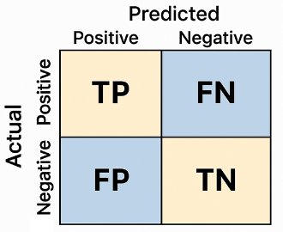

🔹 Visualization Plots
1. Correlation Heatmap
A correlation heatmap is a visualization used in Exploratory Data Analysis (EDA) to show the relationship between different features in a dataset. It displays correlation values between variables using different colors, making it easier to identify patterns and dependencies.
The correlation value usually ranges from -1 to +1:
- +1 → Strong positive correlation (both variables increase together)
- 0 → No correlation
- -1 → Strong negative correlation (one variable increases while the other decreases)
In this project, a correlation heatmap will be used to analyze the relationship between patient clinical features such as age, blood pressure, cholesterol, glucose level, and BMI. It helps identify which features are strongly related to each other and to the disease risk variable.
This visualization is useful for detecting multicollinearity and selecting relevant features for the machine learning models. Features that show very high correlation with each other may be redundant, while features strongly correlated with the target variable are important for accurate disease prediction.

2. ROC Curve
The ROC (Receiver Operating Characteristic) Curve is a graphical representation used to evaluate the performance of a classification model. It shows how well the model can distinguish between positive and negative classes.
The ROC curve plots True Positive Rate (TPR) on the Y-axis against False Positive Rate (FPR) on the X-axis at different classification threshold values.
The formulas used are:
- True Positive Rate (TPR) / Recall
$$TPR=\frac{TP}{TP+FN}$$
- False Positive Rate (FPR)
$$FPR=\frac{FP}{FP+TN}$$
Where:
- TP = True Positive
- TN = True Negative
- FP = False Positive
- FN = False Negative
In this project, the ROC curve will be used to compare the performance of Logistic Regression, KNN, and SVM models. A model whose ROC curve is closer to the top-left corner indicates better classification performance. The Area Under the Curve (AUC) value is also used to measure the model’s overall ability to distinguish between disease and non-disease cases.

- Required topics from the subject:
🔹 Strings
Strings are used for handling textual data such as column names and labels. They help in data preprocessing and formatting outputs.

🔹 Pointers
Pointers are a concept in C language used to store memory addresses. While not directly used in Python, understanding pointers helps in grasping memory management concepts.

🔹 Files
File handling is used to read datasets (CSV files) and store outputs. Functions like read_csv() help in loading data for processing.

- Platform Required:
The development and implementation of this project will require the following platforms:

Visual Studio Code:
Visual Studio Code will be used as the main code editor for writing and managing Python scripts. It provides useful features such as syntax highlighting, debugging tools, and extensions for Python development.

Jupyter Notebook:
Jupyter Notebook will be used for implementing and testing the machine learning pipeline. It allows step-by-step execution of code, visualization of data, and easy documentation of results, which is helpful for tasks like data preprocessing, exploratory data analysis, and model evaluation.

Python IDLE:
Python IDLE can also be used for running and testing small Python programs or scripts related to the project. It provides a simple environment for executing Python code and checking outputs quickly.

These platforms together provide an efficient environment for developing, testing, and analyzing the machine learning models used for disease risk prediction.

- Books and Link Sources:
📚 Books
“Hands-On Machine Learning with Scikit-Learn and TensorFlow” – Aurélien Géron
Covers practical implementation of ML models and preprocessing techniques.

“Pattern Recognition and Machine Learning” – Christopher Bishop
Provides theoretical understanding of machine learning concepts.

“Python for Data Analysis” – Wes McKinney
Focuses on data handling using Pandas and NumPy.

“Introduction to Machine Learning with Python” – Andreas Müller
Beginner-friendly guide for implementing ML algorithms.

🌐 Online Sources
https://scikit-learn.org
https://pandas.pydata.org
https://www.kaggle.com
https://matplotlib.org

